Practical No:-14

X. Program Code:
import java.net.InetAddress;
import java.net.*;
import java.io.*;

public class InteDemo {
public static void main(String[] args) {
try {
InetAddress ia = InetAddress.getLocalHost();
String ab = ia.getHostName();
System.out.println(ab);
String str = ia.getHostAddress();
System.out.println(str);
} catch (Exception e) {
e.printStackTrace();
}
}
}
OUTPUT:-
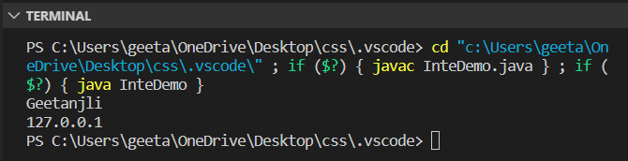
XII.Exercise
Q1. Develop a program using the InetAddress class to retrieve IP address of computer when hostname is entered by the user
import java.io.*;
import java.net.*;

public class Main {
public static void main(String[] args) {
try {
InetAddress ip = InetAddress.getByName("Geetanjli Deshmukh");

System.out.println("Host Name: " + ip.getHostName());
System.out.println("IP Address: " + ip.getHostAddress());
} catch (Exception e) {
System.out.println(e);
}
}

@Override
public String toString() {
return "Main[]";
}

}

OUTPUT:
